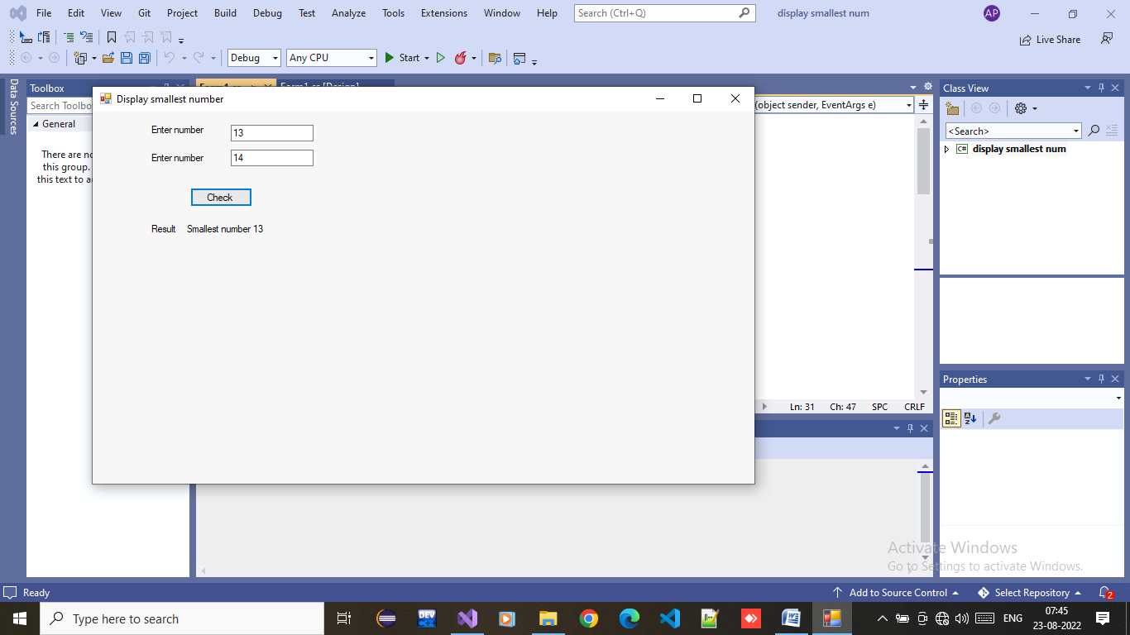

using System;

using System.Collections.Generic;

using System.ComponentModel;

using System.Data;

using System.Drawing;

using System.Linq;

using System.Text;

using System.Threading.Tasks;

using System.Windows.Forms;

namespace display_smallest_num

{

public partial class Form1 : Form

{

public Form1()

{

InitializeComponent();

}

private void Form1_Load(object sender, EventArgs e)

{

}

private void button1_Click(object sender, EventArgs e)

{

int n1=Convert.ToInt32(textBox1.Text);

int n2 = Convert.ToInt32(textBox2.Text);

if(n1<n2)

{

label4.Text = "Smallest number " + n1;

}

else

{

label4.Text = "Smallest number " + n2;

}

}

}

}